Title of the Document: | PARAMETERS IN TABLEAU
Author:
Project Name:

Table of Contents
parameters used in filters .……………………………………………………………………………..1
parameters used in calculations………………..………………………………………………...2
parameters used in reference lines …………………………………………………………...3
PARAMETERS USED IN EXTENSIONS PART IN DASHBOARD……………………………………………..4

Parameters are dynamic values that can replace constant values in
- calculations
- filters
- Reference lines.
PARAMETERS IN TABLEAU SHOWN IN VIOLET COLOR

Create a parameter
Follow the instructions below to create a new parameter from the Data pane.
- In the Data pane, click the drop-down arrow in the upper right corner and select Create Parameter.
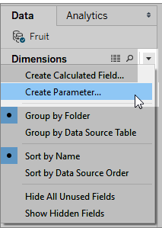

In the Create Parameter dialog box, give the field a Name.
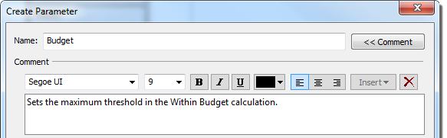
- In Tableau Desktop, you can optionally write a Comment to describe the parameter.
- Specify the data type for the values it will accept:
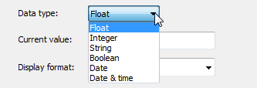

- Specify a current value. This is the default value for the parameter.
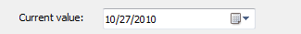
- Specify the display format to use in the parameter control (Tableau Desktop only).
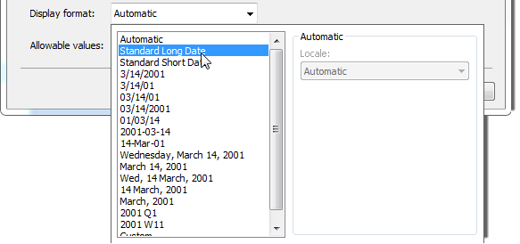
- Specify how the parameter will accept values. You can select from the following options:
  - All - the parameter control is a simple type in field.
  - List - the parameter control provides a list of possible values for you to select from.
  - Range - the parameter control lets you select values within a specified range.
The availability of these options is determined by the data type. For example, a string parameter can only accept all values or a list. It does not support a range.
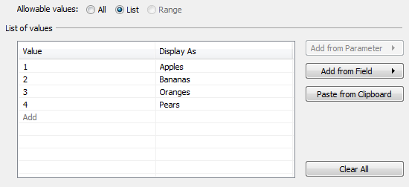
If you select Range you must specify a minimum, maximum and step size. For example, you can define a date range between January 1, 2010 and December 31, 2010, with the step size set to 1 month to create a parameter control that lets you select each month in 2010.
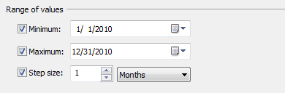

Edit a parameter
You can edit parameters from the Data pane or the parameter control. Follow the instructions below to edit a parameter:
- Do one of the following:
  - Right-click (Control-click ) the parameter in the Data pane and select Edit.
  - Select Edit Parameter on the parameter control card menu.
- In the Edit Parameter dialog box, make the modifications as necessary.
- When finished, click OK. The parameter is updated along with any calculations that use it.

Use a parameter in a calculation
Parameters give you a way to dynamically modify values in a calculation. Rather than manually editing the calculation (and all dependent calculations), you can use a parameter. Then when you want to change the value, you open the parameter control, change the value, and all of the calculations that use that parameter are updated.
To use a parameter in a calculation, drag the parameter from the Data pane and drop it in the calculation editor, either at a new location in the formula or to replace a part of the current formula:

Use a parameter in a filter
A list of parameters is available in the drop-down lists on the Top tab of the Filter dialog box. Select the parameter you want to use in the filter.
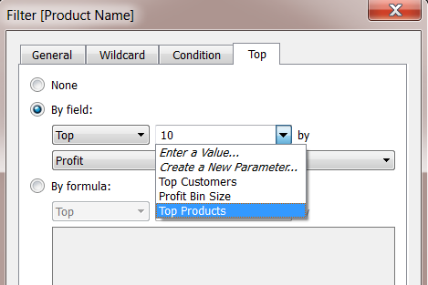
To show the parameter control, right-click the parameter in the Data pane and select Show Parameter Control. Use the parameter control to modify the filter to show the top 10 products, 15 products, 20 products, and so on.
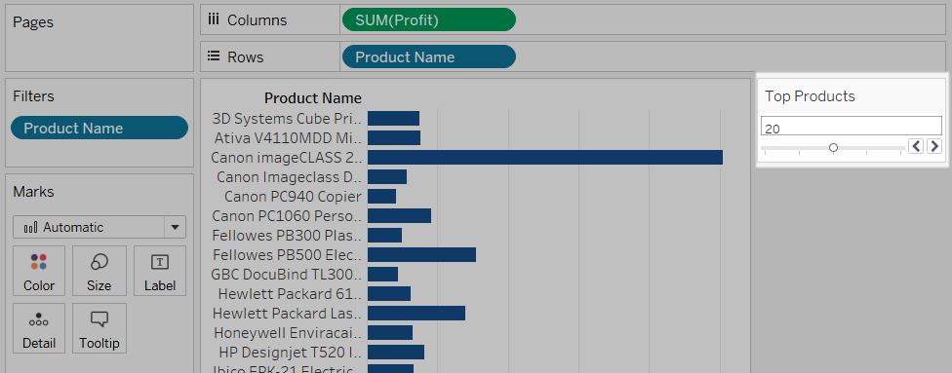

Use a parameter in a reference line
Parameters give you a way to dynamically modify a reference line, band, or box. For example instead of showing a reference line at a fixed location on the axis, you can reference a parameter. Then you can use the parameter control to move the reference line.
A list of parameters is available in the Value drop-down list in the Add Reference Line, Band, or Box dialog box. Select the parameter you want to use.
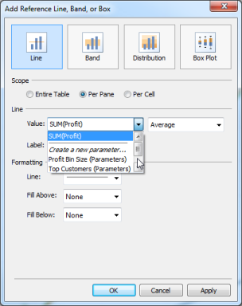
The reference line is drawn at the Current Value specified by the parameter. To open the parameter control, right-click (Control-click on a Mac) the parameter in the Data pane and then select Show Parameter Control. Use the parameter control to change where the reference line is drawn.

All The Above topics we build a real time scenarios in Tableau workbook.
Top N Results
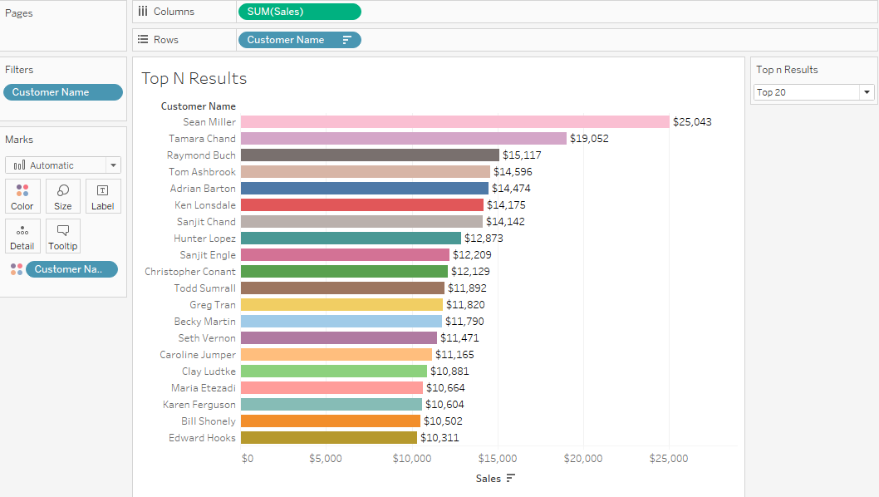
Here we created the Top n Customers based on sales ,now we can dynamically change the data by
Using the parameter on right side of the view .
Bottom N Results
2) Here we are showing the bottom N customers based on sales, now we can dynamically change the data by Using the parameter on right side of the view .

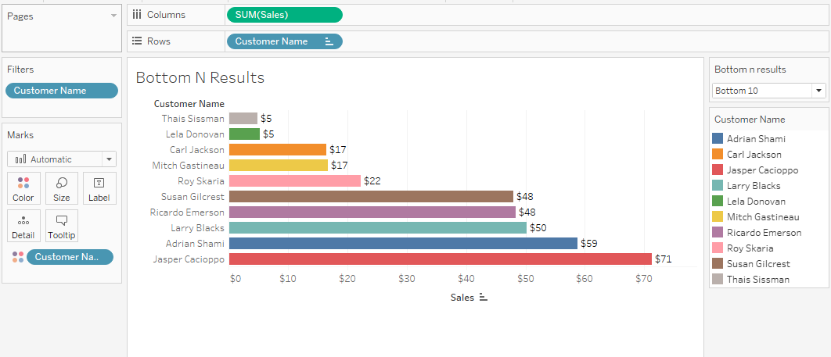
3) TOP N AND BOTTOM END RESULTS AT ATIME
Here we are showing the view Top n And Bottom N results at a time (by Using Sets concept → combined set ) used by Parameters
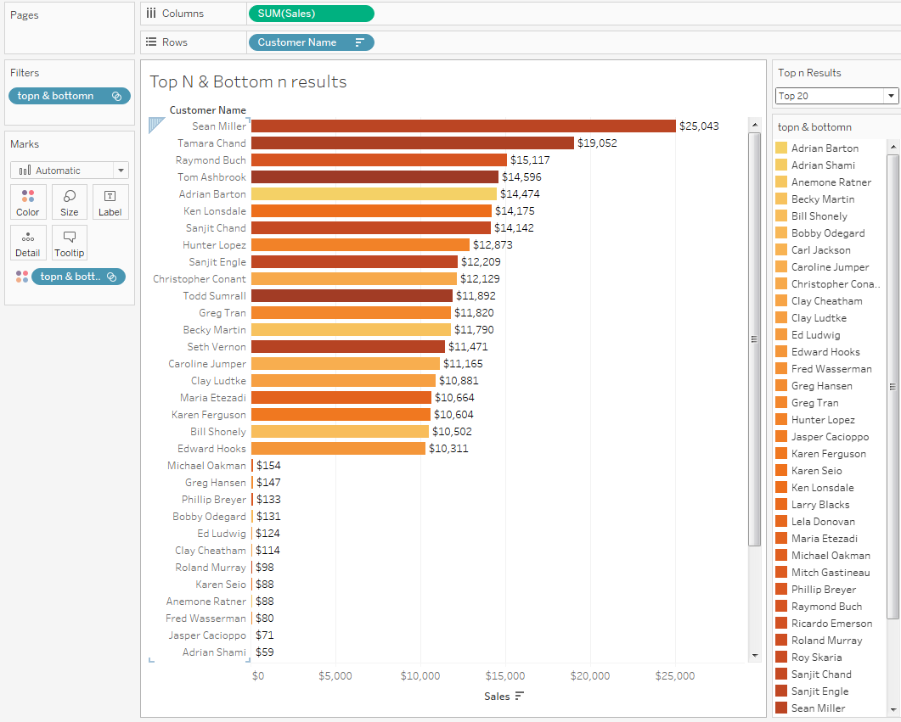
In this view Created a top n Set and Bottom end Set and created that both the fields as combined field
That are used in the parameter.
Then we can show the result both Top And Bottom end result at a time in a same view .

- CHOOSE DATES DYNAMICALLY(Y/Q/M/W/D)
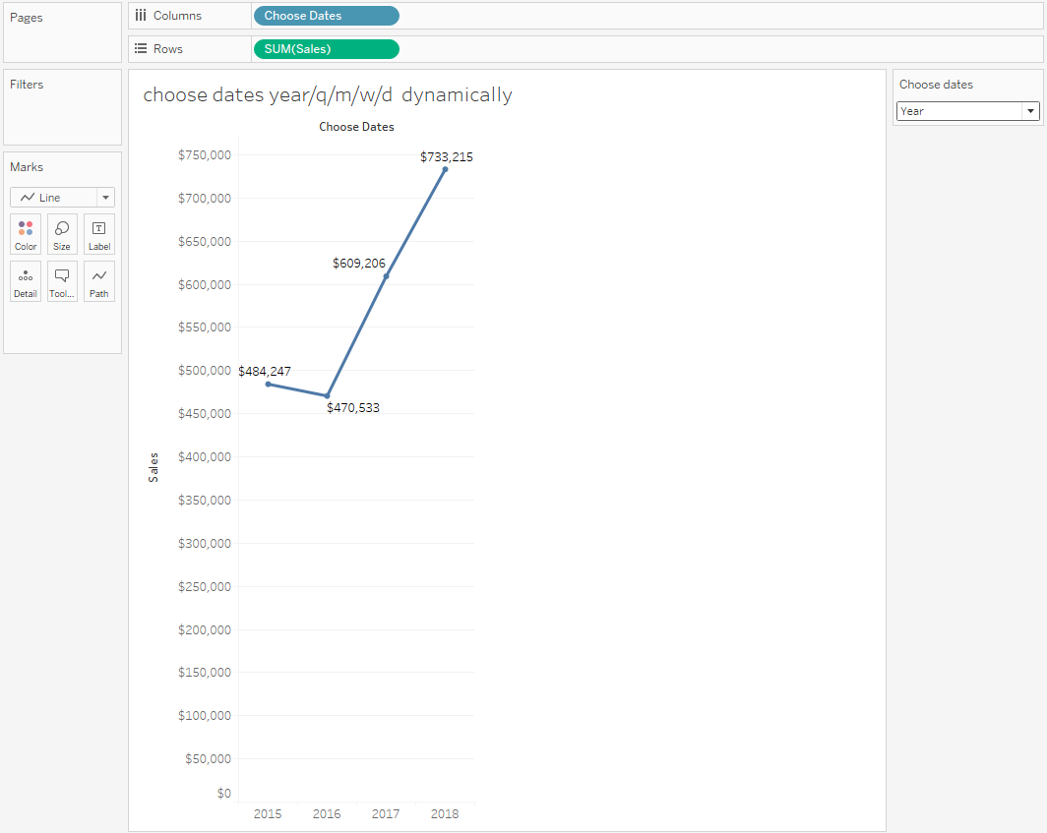
By changing the above view using the parameter Dynamically.
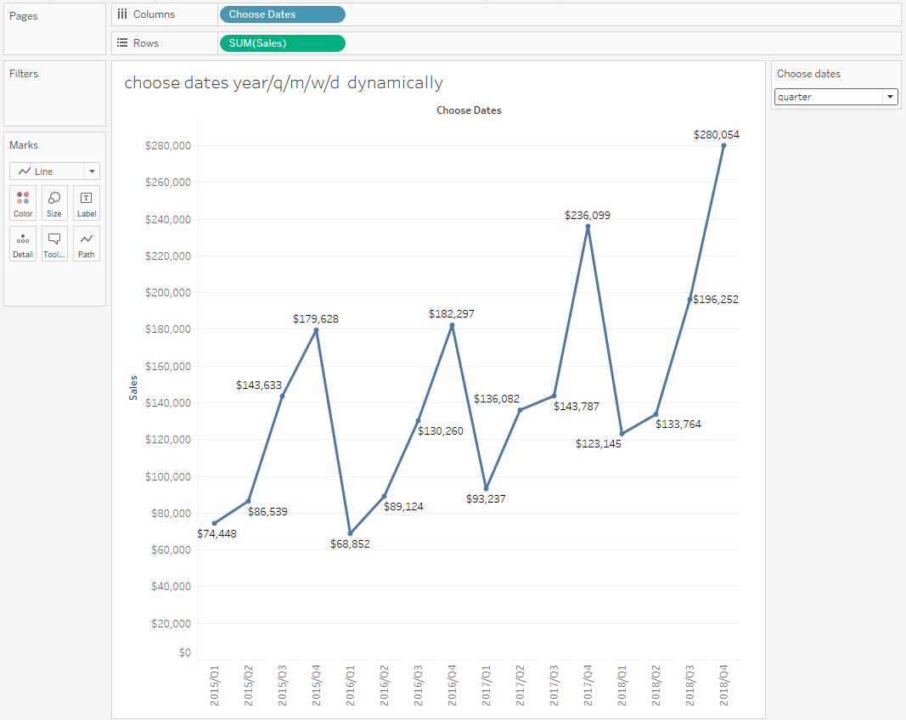

Here we are showing the quarter wise sales by using parameter
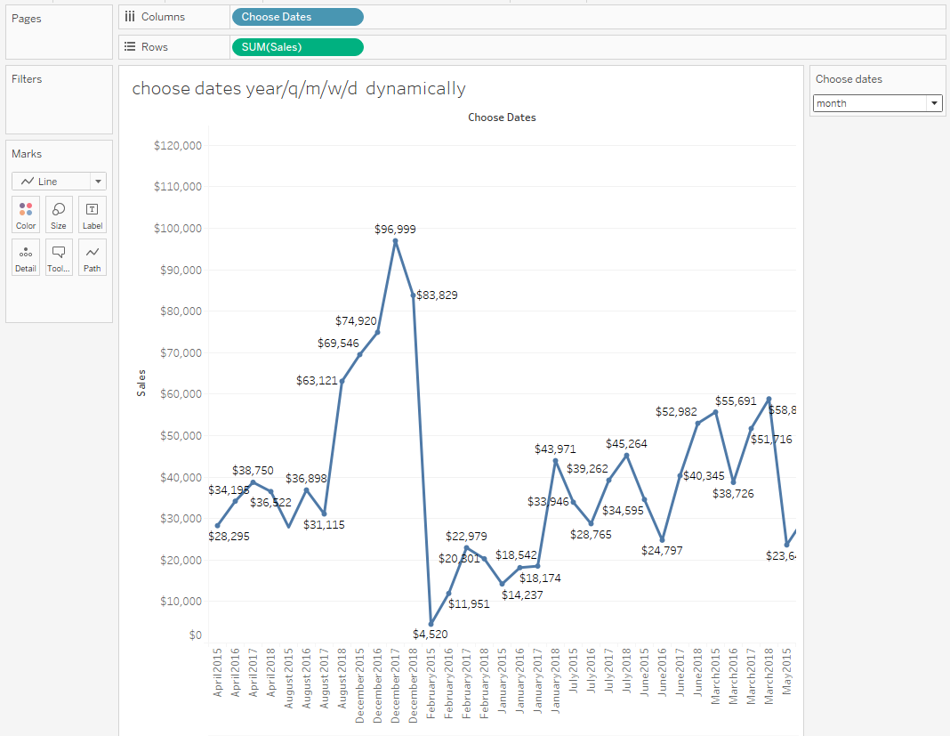
Here we are showing the Month wise sales by using parameter .
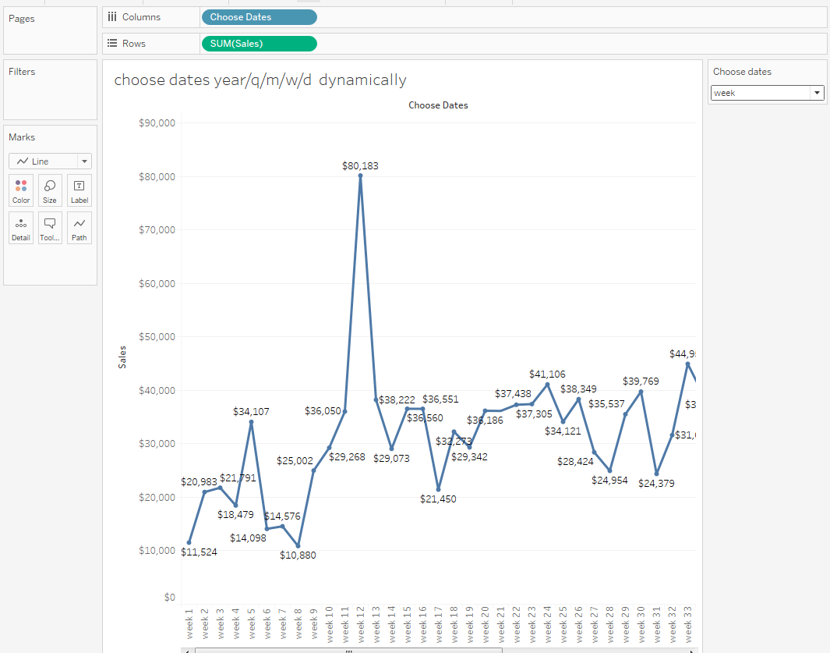
Here we are showing the Week wise sales by using parameter .
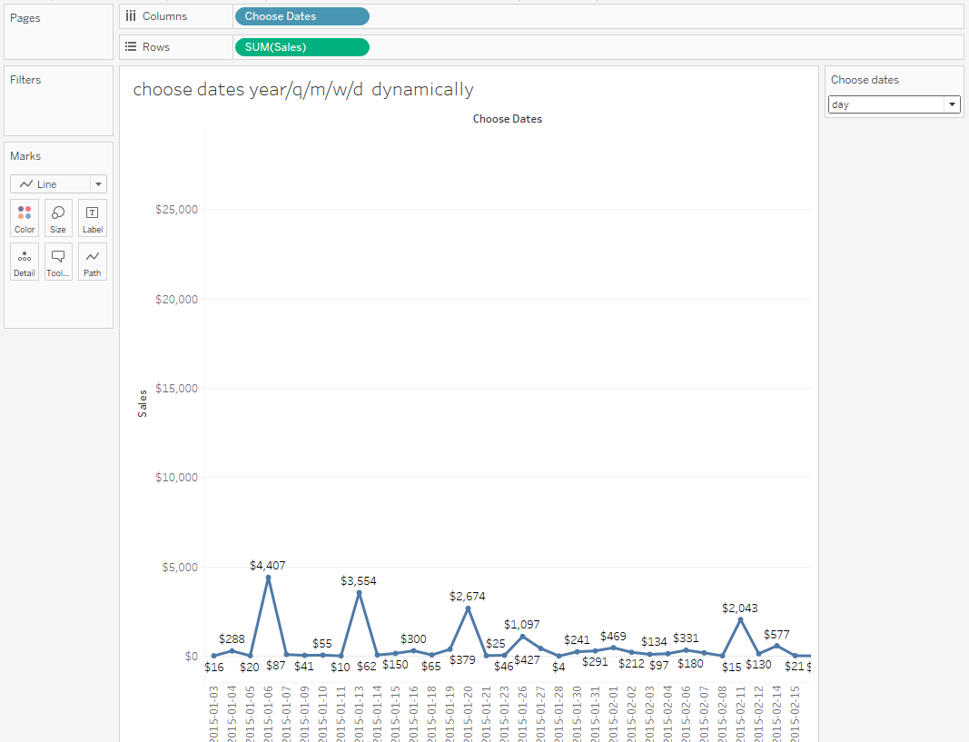
Here we are showing the Day wise sales by using parameter .

- PARAMETERS USING IN DYNAMIC SELECTION
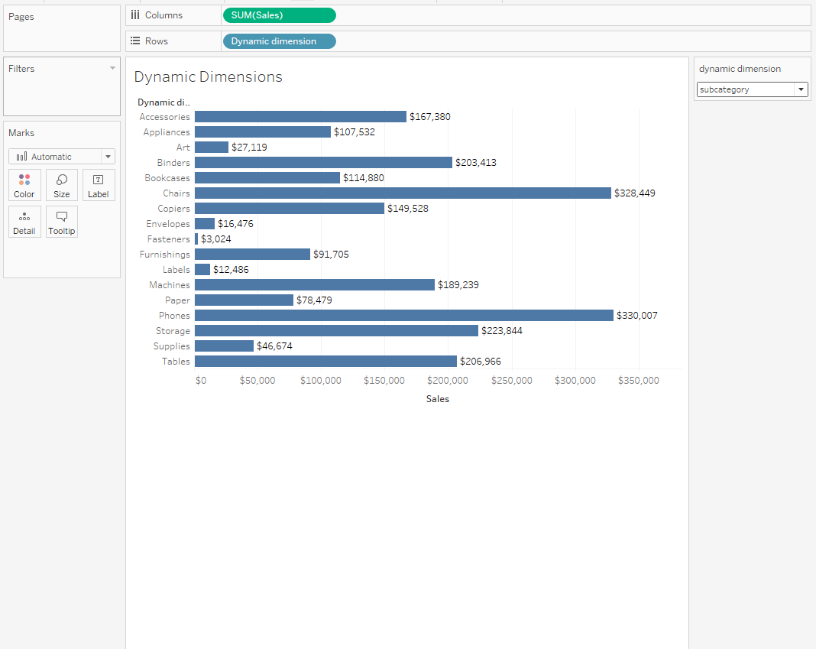
In Dynamic selection parameters call All the dimension in the datasource , dimensions can change their sales through parameters .
- PARAMETERS USING IN DYNAMIC MEASURES
Here we can pass multiple measures using these Dynamic measure parameters using in calculation field.
Here dynamically change the measures for any dimension ex:- sub-category
By clicking the dynamic measure parameter can change the values.

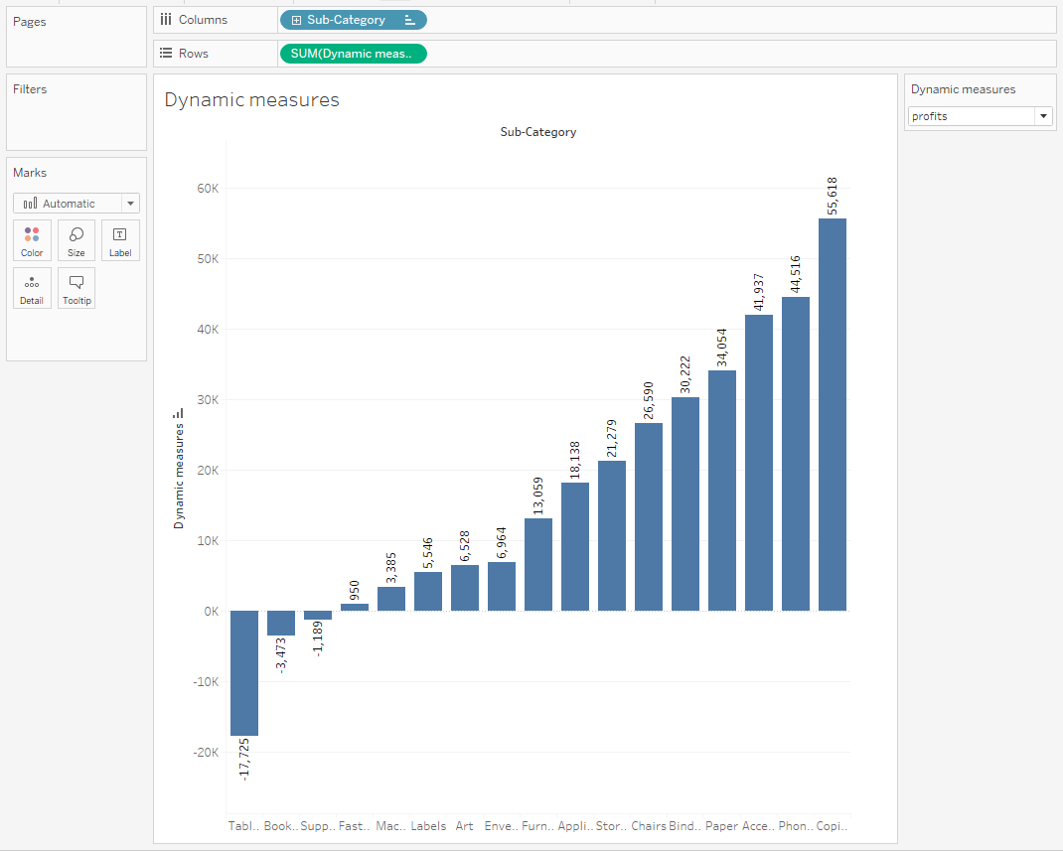

5. Dynamic dimension &Dynamic measure used both at a time

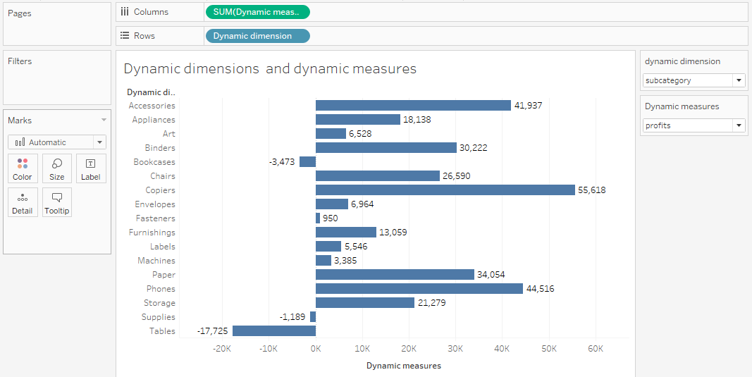

Here we clicking the parameter BOTH measures and dimensions can used to show the data visually.

6. PARAMETERS USED IN REFERENCE LINE
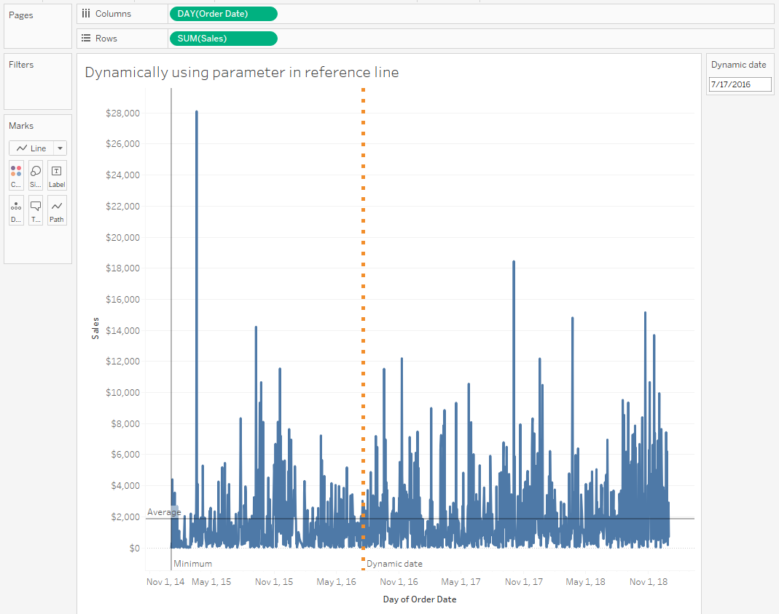
This is the use case of parameter using in reference line by seeing the targets what we given in reference line which was shown in the above fig.
In Above fig The orange line Referred to Reference line to change the day of order date dynamically to chance the reference line .

- HOW TO USE PARAMETERS IN EXTENSIONS IN DASHBOARD
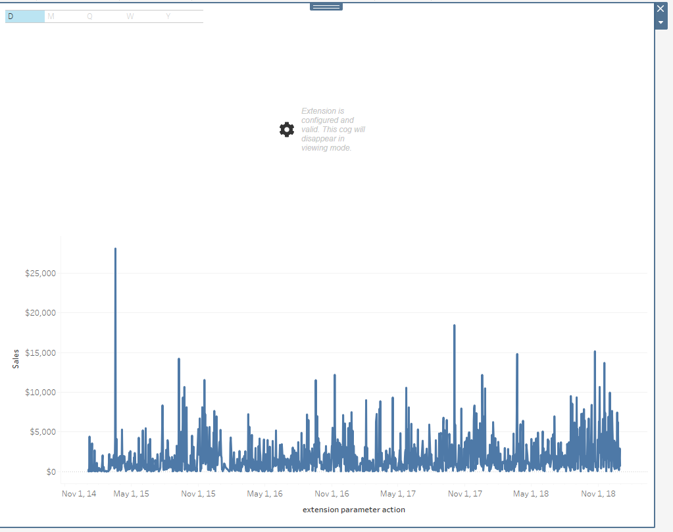
Here we are using new implementation of extensions using parameters by seeing the above figure
We are giving the button model by clicking the button it will change the data as per the input given
Here we selected field (order date) day wise

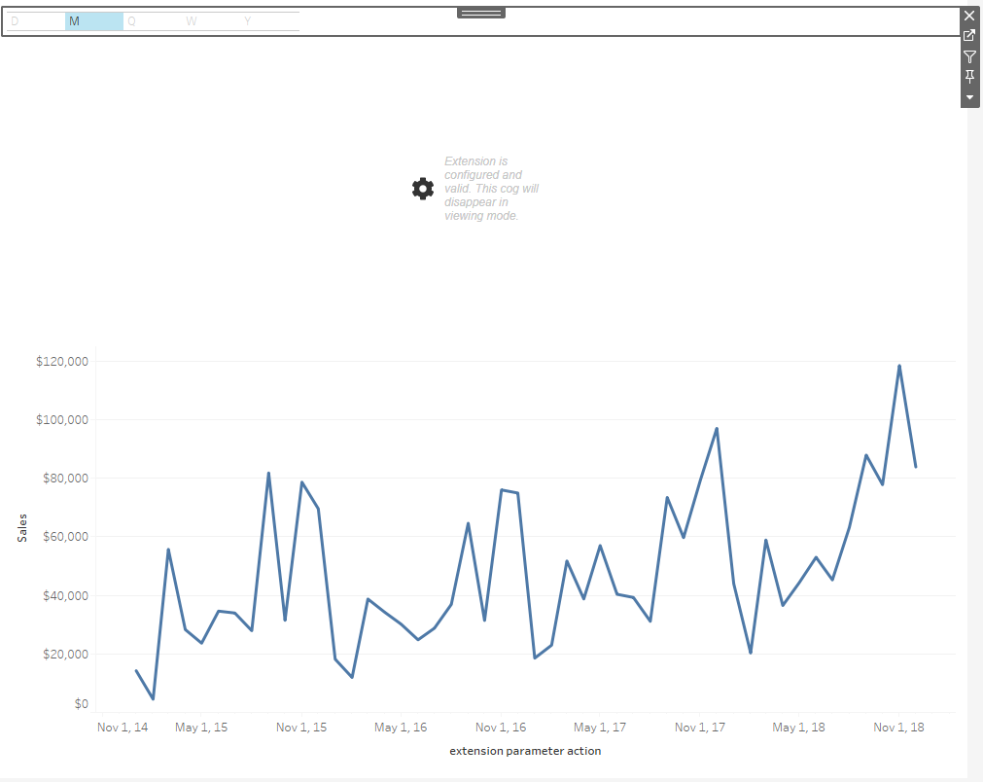
Here the same thing dynamically change the view by using here button system not a parameter by using the extensions option in dashboard showing the view in month wise .

Here the same thing dynamically change the view by using here button system not a parameter by using the extensions option in dashboard showing the view in month wise .

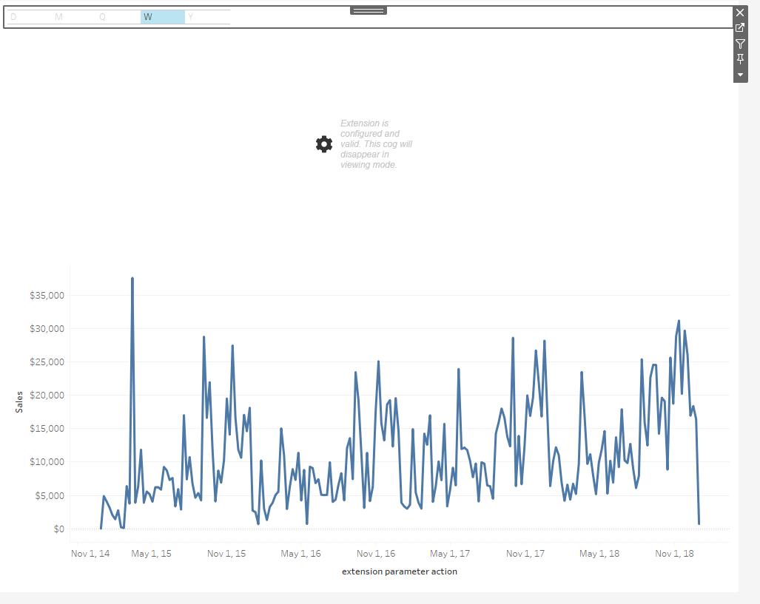
Here the same thing dynamically change the view by using here button system not a parameter by using the extensions option in dashboard showing the view in week wise .

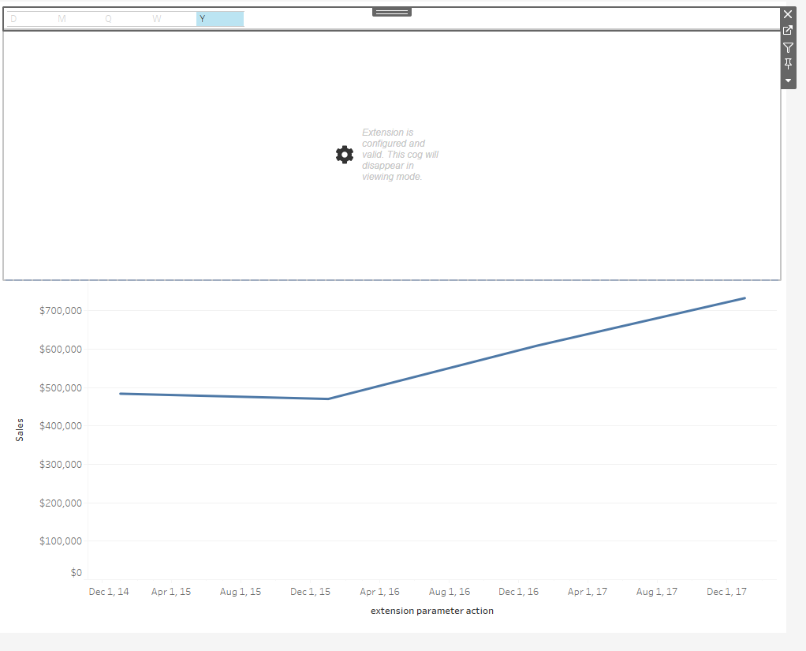

Here the same thing dynamically change the view by using here button system not a parameter by using the extensions option in dashboard showing the view in Year wise .
How to filter across multiple data sources using parameter

- Taking two data sources from tableau coffee chain and superstore data .by using both the data source scenario.
- I imported two data sources from website related to this scenario.

- 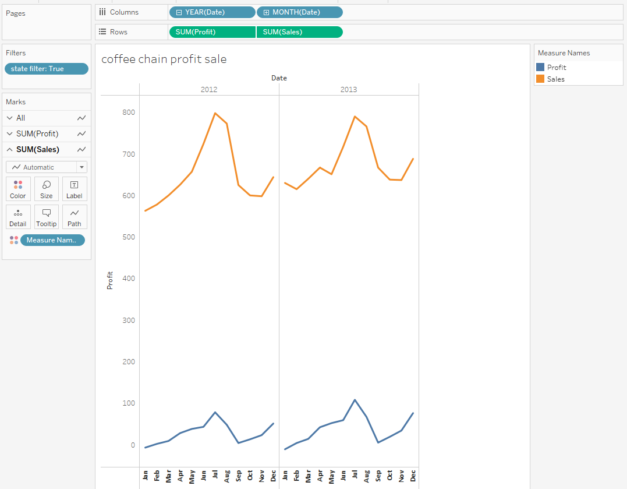

- Step 1: Create the initial view:-
1) Open Tableau Desktop and connect to the Superstore sample data source.
2) (If applicable) On the Data Source page, drag the Orders table to the canvas.
3) Select Data > New Data Source, and then connect to the Coffee Chain data source.
- On the Data Source page, drag the Coffee Chain Query table to the canvas, and then click the sheet tab.
- Drag Date to the Columns shelf.
  - On the Columns shelf, click the plus icon next to Year (Date) to also show Quarter, and Month. Remove Quarter.
- Drag Profit and Sales to the Rows shelf.
- Right-click Sales, and make it Dual Axis.
- Right-click the new axis, and select Synchronize axis.
- Select Worksheet > New Worksheet and then select the Superstore data source in the Data pane.
- Drag Order Date to the Columns shelf.
On the Columns shelf, click the plus icon next to Year (Order Date) to also show Quarter, and Month. Remove Quarter.
- Drag Sales to the Rows shelf.
- Drag Category to Color, and select Bar from the Marks drop-down list.
- Create a new dashboard, and then drag Sheet 1 and Sheet 2 to the view.

- 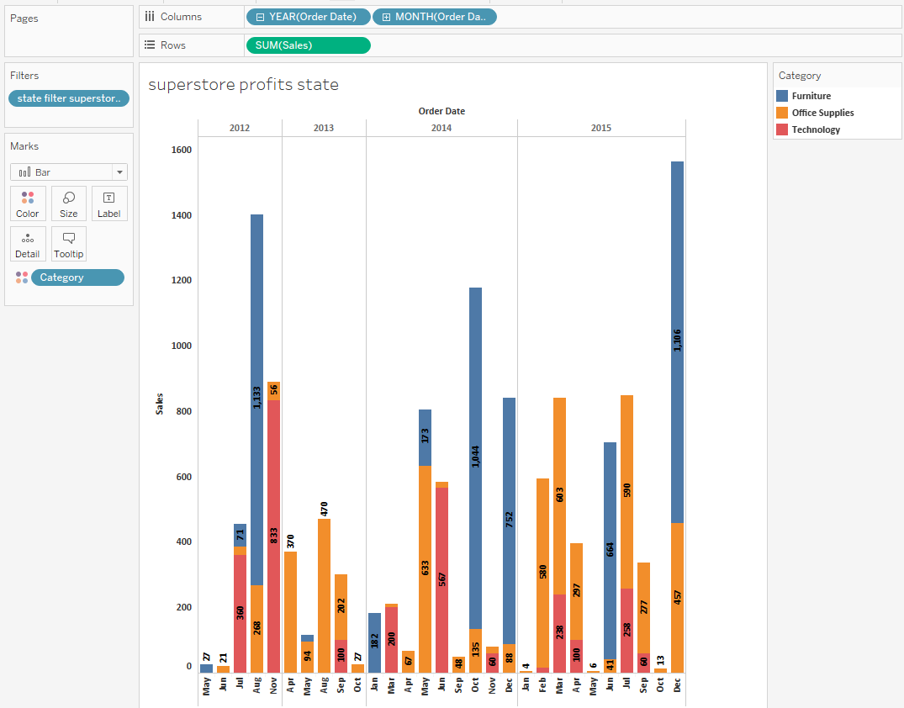

Step 2: Create a custom parameter and use it in a calculated field.

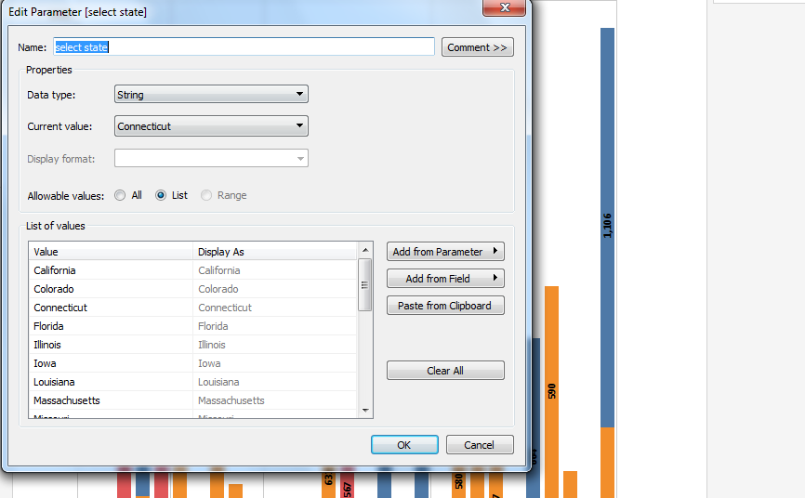

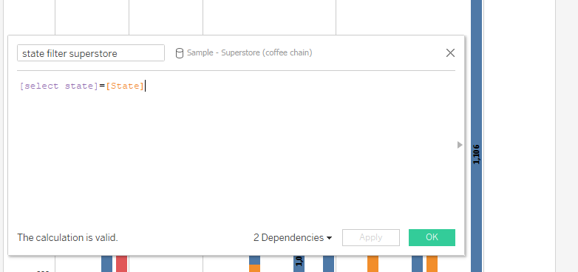

Step 3: Use the parameter
- Go to the dashboard, click the drop-down arrow for one of the views, and then select parameters ->select state
- Select a state from the parameter control.
  - Note: Views that use either or both data sources refresh to show data from the selected state.
